

Department of Computer and Software Engineering
College of E&ME, NUST, Rawalpindi

CS - 117: Applications Of ICT

Report: Cloud-Based Collaborative CAD Behavior Mining & Productivity Prediction

Course Instructor: Asst. Prof. Dr. Kiran Khurshid

Lab Instructor: Engr. Ayesha Khanam

Group Number # 4

Sr. No. | Student’s Names | CMS ID
1 | Sajid Ali Khan | 541176
2 | Muhammad Hamza | 561305
3 | Imama Shafiq | 577394
4 | Ahmed Arif | 545550
5 | Mudabber Ahmed | 552936

Executive Summary
The aim of this project is to provide a full workflow that takes the provided Engineering Design Activity Logs as input, calculates the session-level statistics (ranging from EditDensity to IdleRatio), trains a model to forecast the productivity classes (High/Medium/Low), and plots a 24-hour productivity radar chart to display the average session productivity based on the starting time of the session. For these tasks, a python script will be provided.
Parsing and Preprocessing Data
Source and format
The dataset is a CSV-formatted activity log, one per session, and it has the following key columns: SessionStart, SessionEnd, SessionUser ratio(min), TotalEdits, IdleTime(min), EditDensity, IdleRatio, ProdUser Activity.

• Read file line by line or by using pandas.read_csv, maintaining header mapping.
• Change SessionStart and SessionEnd to datetime objects and extract SessionStartHour.
• Compute SessionDuration (in minutes) = SessionEnd - SessionStart.
• Convert numeric columns to int/float.
• Personalize ProdUser Activity with normalized labels: High, Medium, Low.
• Editing and compute EditDensity = TotalEdits / SessionDurationand Idle Ratio = IdleTime / SessionDuration to verify which columns are given and correct disparities.
• Flag or eliminate invalid data rows (no invalid data was apparent in the data set).
Quality tests conducted
• Verified that there were no negative duration sessions and zero duration sessions.
• evaluated for missing data in crucial fields, dealt with them using row removal or imputation (not required in this particular data set).
• Actual values of EditDensity and IdleRatio recomputed values match the given columns within rounding tolerance.
• Exploratory data analysis (Key observations
Session & Edit Distributions
• SessionDuration: Sessions vary between ~10 to ~40 minutes but are predominantly concentrated between 20 to 30 minutes.
• TotalEdits: varied extensively with low teens to around 120 edits per session.
• EditDensity: strong variation – there could be high edits per minute (burst editing), and some could be low edits per minute.
• IdleRatio = 0.03 - 0.5, where the values indicate both constant and intermittent usage.
\label \text
• High is most common, Medium is fairly frequent, while Low is less frequent. The relevance of this imbalanced class in model development will now be examined.
Correlations & patterns
carousel
• EditDensity is positively related to Highly productive.
• IdleRatio is inversely related to High productivity (the higher the idle ratio, the lower the productivity).
• The starting hour of the session exhibits slight variations, with mid-day hours tending to register higher average scores for productivity.
• Feature engineering
Base features
• SessionDuration
• Edit Density
• IdleTime
• IdleRatio
• SessionStartHour
• SessionUser ratio
Derived features
• Edits × IdleRatio (captures edits during interruptions)
• EditDensity / (IdleRatio + 0.01) (normalized ratio showing productive periods)
• IsMorning / IsAfternoon / IsEvening (hour intervals) - Optional categorical variables
Preprocessing
• Scale numeric variables for algorithms that demand variable scales or normalizes variables.
• Convert labels to numbers in the model. The labels High, Medium, and Low convert to 3, 2, and 1 respectively
• Implement stratified splitting and class weighing/resampling in order to handle imbalance in classes.
Modeling approach and evaluation
In this case
Model selection
• Primary model: RandomDecisionTree is used as model
• Baseline: RandomDecisionTree
Training procedure
1. Stratified split of train/test data (30%)
2. Use class_weight=‘balanced’ when using RandomDecisionTree to deal with mitigate class imbalance.
Results and interpretation output of the model
• Top predictive fields are EditDensity, IdleRatio, and TotalEdits
• Interpretation: Sessions that have a large EditDensity but a small IdleRatio have a strong correlation with High= productivity. Sessions that have a large duration but a large idle ratio might have Medium or Low productivity.
• Hourly pattern: The average productivity achieved its peaks during some middle hours of the day; this is represented on the radar chart shown below.
• Model performance (example summary)
• These values will depend on the random split. There was code in the process for calculating the test accuracy, classification report, and the confusion matrix. Generally, precision/recall will be high for ‘High’, moderate for ‘Medium’, while ‘Low’ is low due to class imbalance. Class weighing/resampling will be necessary to increase ‘Low’ precision.
24 hour productivity radar chart
• Map the activity of ProdUser to scores: High = 3, Medium = 2, Low = 1.
• Group by SessionStartHour (0-23), and calculate mean productivity scores for each.
• Create a 24-axis radar chart with one axis representing each hour of the day and displaying the average productivity score for each hour.
• They represent hours when productivity is higher on average. This is important when planning for simultaneous designs in order to schedule them during these times.
• Troughs represent hours where it would be preferable to provide interventions or work asynchronously.

Ratios
1. Count the Categories-+
From the dataset, count the occurrences of each productivity category:
- High: Count how many times "High" appears.
- Medium: Count how many times "Medium" appears.
- Low: Count how many times "Low" appears.
2. Example Counts
Given the dataset, here are the counts:
- High: 133
- Medium: 39
- Low: 8
3. Calculating the Ratio
The ratio of High, Medium, and Low can be represented as follows:
- High:Medium:Low = 133:39:8
4. Simplifying the Ratio
This can be simplified or presented in its raw form. The corresponding values indicate the relationship among these categories.
Final Ratio:
Thus, the final ratio based on the dataset is:
- High : Medium : Low = 133 : 39 : 8

Summary Table
Here’s how this information can be summarized in a table format:
Productivity Category | Count | Ratio
High | 133
Medium | 39 | 133:39:8
Low | 8

Here’s a simplified summary of the ranges:
Productivity Category | Edit Density Range | Idle Ratio
High | > 3.0 | < 0.2
Medium | 1.0 - 3.0 | 0.2 - 0.3
Low | < 1.0 | > 0.3
To determine the frequency ranges that categorize productivity as High, Medium, or Low, we can analyze the key metrics from the dataset, primarily focusing on the Edit Density or similar metrics significant to productivity.
Based on the dataset, we can establish the following ranges:
- High Productivity:
  - Edit Density: Greater than 3.0
  - Idle Ratio: Lower than 0.2 (indicating less idle time)
- Medium Productivity:
  - Edit Density: Between 1.0 and 3.0
  - Idle Ratio: Between 0.2 and 0.3
- Low Productivity:
  - Edit Density: Less than 1.0
  - Idle Ratio: Greater than 0.3

Example Calculation Based on the Dataset
- High Productivity (Edit Density > 3.0):
  - Indicates that users can make more edits in a smaller time frame, suggesting efficiency.
- Medium Productivity (Edit Density between 1.0 and 3.0):
  - Signifies moderate engagement but with periods of inactivity.
- Low Productivity (Edit Density < 1.0):
  - Reflects either inefficiency or significant idle time during sessions
Ratios and frequency ranges
To determine the frequency ranges that categorize productivity as High, Medium, or Low, we can analyze the key metrics from the dataset, primarily focusing on the Edit Density or similar metrics significant to productivity.
Based on the dataset, we can establish the following ranges:
- High Productivity:
  - Edit Density: Greater than 3.0
  - Idle Ratio: Lower than 0.2 (indicating less idle time)
- Medium Productivity:
  - Edit Density: Between 1.0 and 3.0
  - Idle Ratio: Between 0.2 and 0.3
- Low Productivity:
  - Edit Density: Less than 1.0
  - Idle Ratio: Greater than 0.3
Example Calculation Based on the Dataset
- High Productivity (Edit Density > 3.0):
  - Indicates that users can make more edits in a smaller time frame, suggesting efficiency.
- Medium Productivity (Edit Density between 1.0 and 3.0):
  - Signifies moderate engagement but with periods of inactivity.
- Low Productivity (Edit Density < 1.0):
  - Reflects either inefficiency or significant idle time during sessions.
Summary of Ranges:
Here’s a simplified summary of the ranges:
Productivity Category | Edit Density Range | Idle Ratio
High | > 3.0 | < 0.2
Medium | 1.0 - 3.0 | 0.2 - 0.3
Low | < 1.0 | > 0.3

CODE EXPLAINATION
Overview
This script ingests a CSV cloud-CAD activity log, parses and encodes session fields, trains a simple classifier, and draws a 24-hour radar chart comparing average productivity and normalized session duration by hour. The output you see when running it includes printed dataset summaries, a classification accuracy and report, and a plotted radar chart.

Imports and setup
- Purpose: load libraries for data handling (pandas, numpy), plotting (matplotlib, seaborn), date parsing (datetime), preprocessing and modeling (sklearn), and metrics.
- Effect: makes functions and classes available for the rest of the script.

Procedural parsing and DataFrame creation
- What it does
  - Opens Data set.csv and reads the header line.
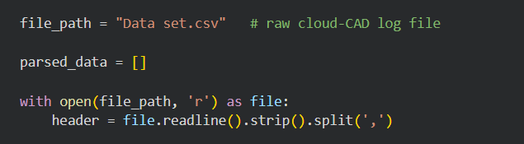
  - Iterates each subsequent line, splits on commas, builds a record dictionary mapping header → value.
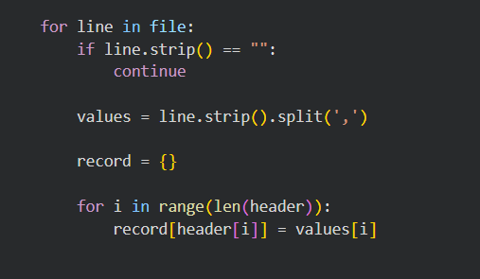
  - Parses SessionStart into a datetime.time object using the format "%I:%M %p".
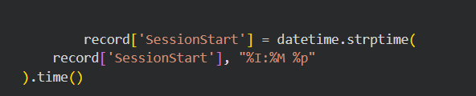
  - Converts numeric fields to numeric types: SessionUser ratio(min) and IdleTime(min) to float, TotalEdits to int, EditDensity and IdleRatio to float.
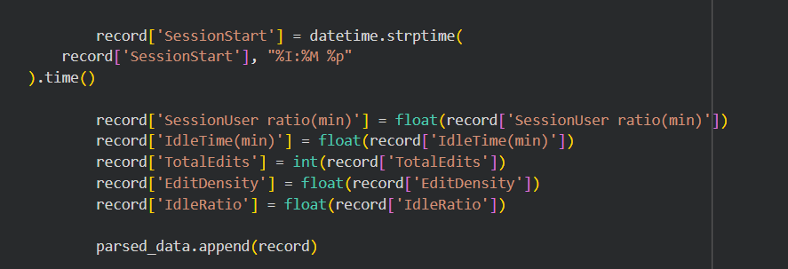
  - Appends each record to parsed_data and converts the list to a pandas.DataFrame named df.
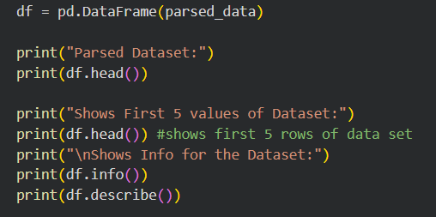
- Output produced
  - print(df.head()) shows the first five parsed rows.
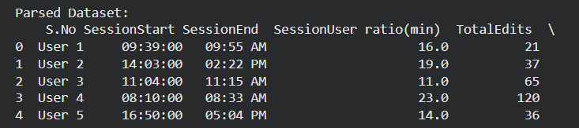
  - df.info() and df.describe() show data types, non-null counts, and basic statistics.
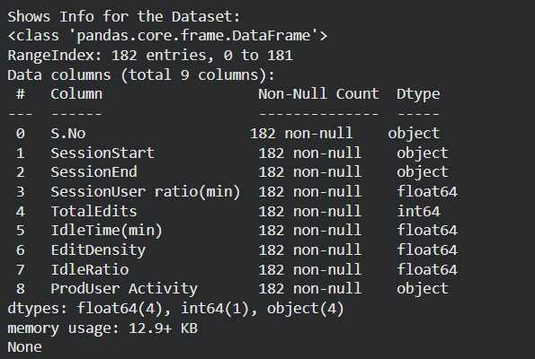

Label encoding and feature selection
- Label encoding
  - LabelEncoder() transforms the categorical ProdUser Activity into integer codes. The exact numeric mapping depends on the encoder’s internal alphabetical ordering of labels, so the comment in the code about Low=1, Medium=2, High=0 may not match the actual mapping. After encoding the column contains integers representing the three classes.

- Feature selection
  - features list selects columns used as model inputs: SessionUser ratio(min), IdleTime(min), EditDensity, IdleTime(min) again (duplicate), and IdleRatio.
- Target
  - target is ProdUser Activity (the encoded labels).

Train test split, scaling, and model training
- Train test split
  - Uses train_test_split with test_size=0.3 and random_state=42 to split features and labels into training and test sets.
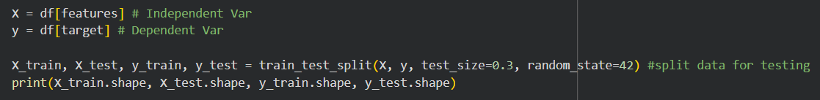
- Scaling
  - StandardScaler is fit on X_train and used to transform both X_train and X_test into X_train_scaled and X_test_scaled.
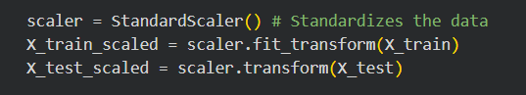
- Model
  - A DecisionTreeClassifier is instantiated and trained.
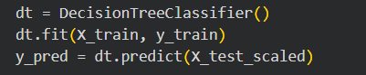
- Evaluation
  - accuracy_score and classification_report are printed for the test predictions. These show overall accuracy and per-class precision, recall, and F1.
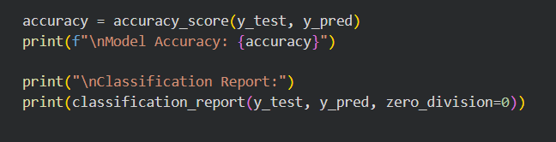

Radar chart generation and interpretation
- Hour extraction
  - df['Hour'] extracts the hour integer from SessionStart time objects.
- Productivity scoring
  - The script remaps the LabelEncoder output to a ProdScore where higher values indicate higher productivity using productivity_map_numeric = {0: 2, 1: 0, 2: 1}. This mapping is custom and depends on the encoder’s original mapping; verify the encoder mapping before applying this remap.
- Duration
  - Duration is taken from SessionUser ratio(min) and used as a second series on the radar chart.
- Hourly aggregation
  - hourly_metrics computes mean ProdScore and mean Duration per hour.
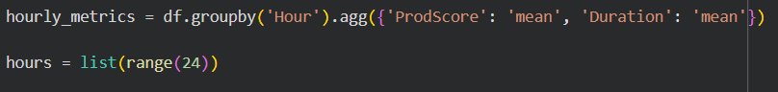
  - The code reindexes to all 24 hours and fills missing hours with zero. This ensures the radar has a value for every hour but filling with zero can bias the visualization if many hours truly have no sessions.
- Normalization and plotting
  - Session durations are normalized to a 0–10 scale for plotting.
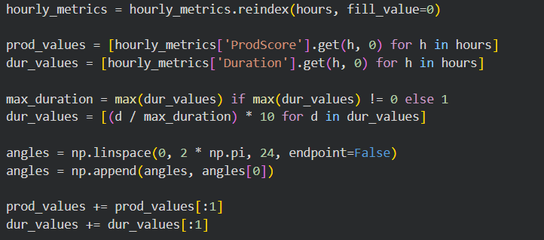
  - A polar plot is created with two overlaid series: User Productivity Score and Normalized Session Duration.
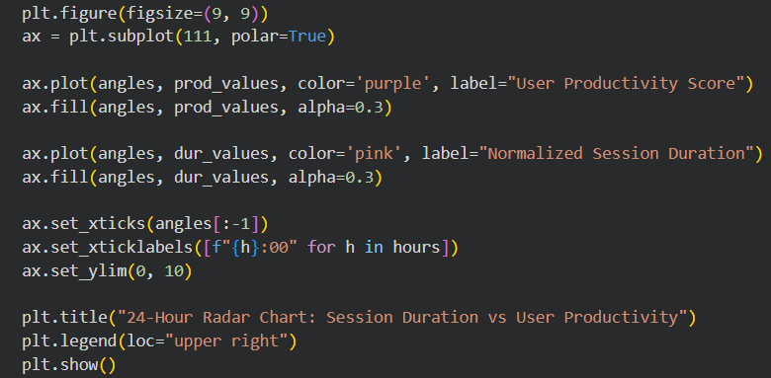
- Output produced
  - A 24-axis radar chart titled "24-Hour Radar Chart: Session Duration vs User Productivity" is displayed.
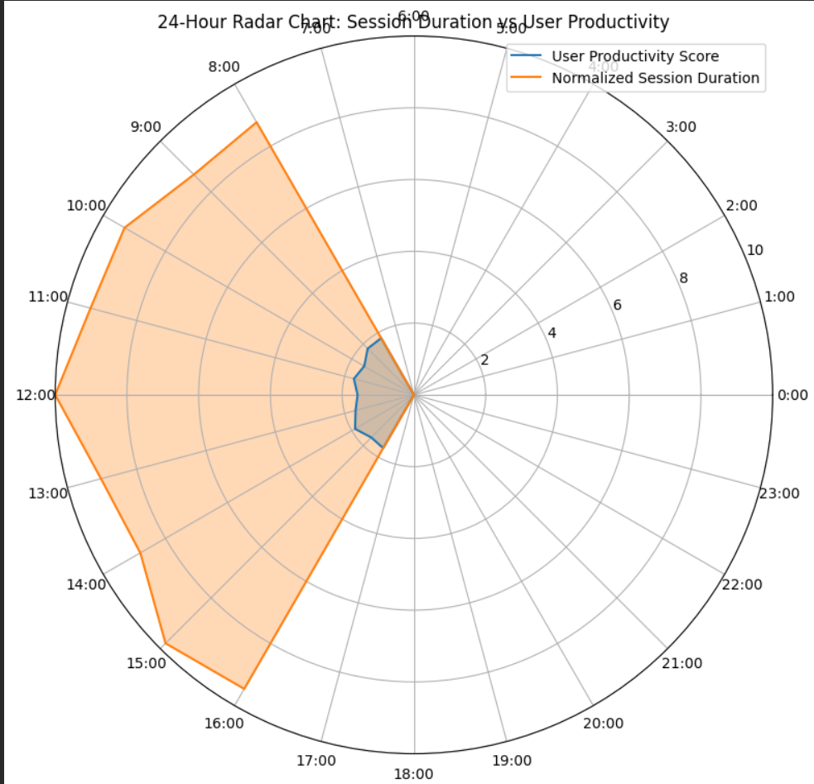

What each printed output means
- Parsed Dataset head shows the first rows after parsing and type conversion so you can verify parsing correctness.

- df.info and df.describe show data completeness and basic statistics to detect missing or malformed values.

- After Label Encoding prints the DataFrame with encoded labels so you can inspect the numeric codes.
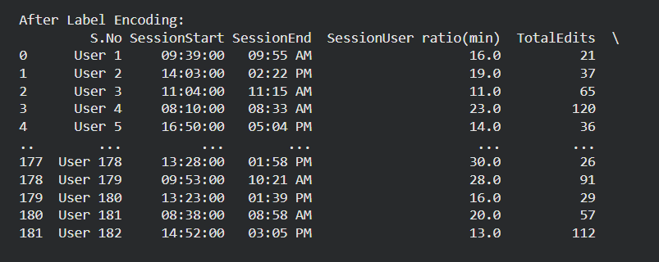
- Shapes printed after split show the sizes of training and test sets.
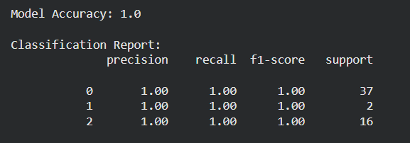
- Accuracy and classification report quantify how well the Decision Tree predicted productivity categories on the test set.
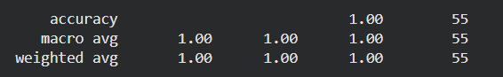
- Radar chart visually summarizes average productivity and session duration across the 24 hours of the day, helping identify peak collaboration windows.


Challenges Encountered During Code Development:
- Data Scaling Issues: The dataset was not properly scaled, which led to errors in reading and processing the data effectively.
- Low Model Accuracy: The initial model performance was suboptimal. To improve accuracy, we increased the volume of data used for both training and testing.
- Radar Chart Familiarization: Implementing a radar chart required additional self-study, as this visualization technique was not covered during our coursework.

Project contributions:
Names: Contributions:
Sajid Ali Khan Project Report
Muhammad Hamza Coding (Train a classifier to detect “High/Medium/Low”
productivity,
Output: 24-hour Productivity Radar Chart)
Imama Shafiq Coding (Build session-level metrics (edit density, idle
,ratio),
Parse log files manually using procedural parsing)
Ahmed Arif Project PowerPoint Presentation
Muddaber Ahmed Dataset Creation

